**EE 271 FALL 2014 MIDTERM Instructor : Cenk Efeler 24.11.2014**

1. The voltage and current at the terminals of the circuit element shown vary according to the relationships given below.
2. Find the maximum value of power delivered o the circuit element.
3. Find the average value of power between times  s.

20 points









 V i=10sin A

1. The voltage between the terminals a,b of the circuit shown has been measured as 5V using and ideal voltmeter.What is the value of ?

20 points

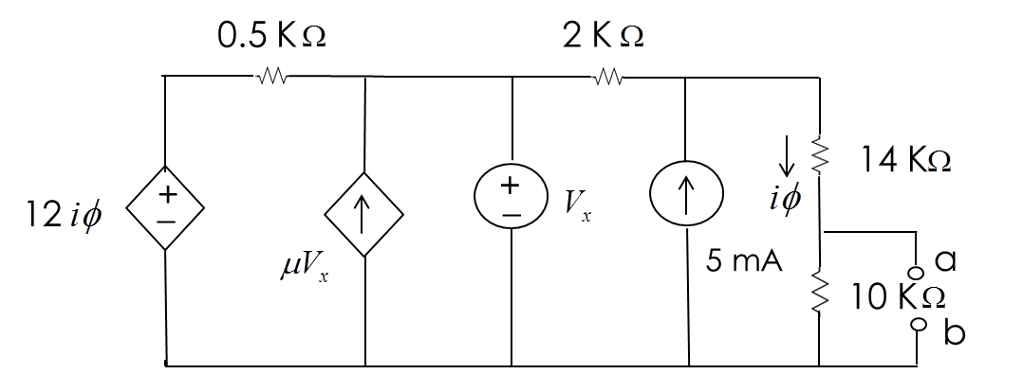

1. **a)** Calculate the current I.

**b)**Calculate the voltages V1 and V2.

1. points

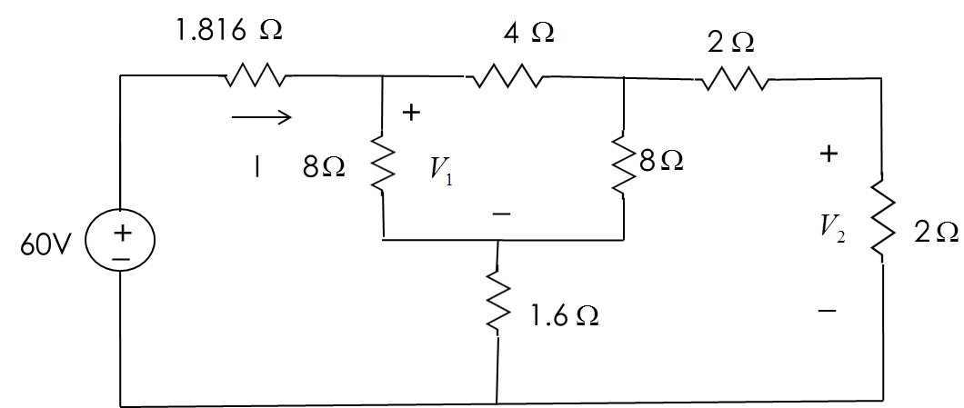

**4-** The variable dc current source in the circuit is adjusted so that the power developed by the 6A current source is zero.Find the value of idc.

**a)** Using the mesh-current method.

**b)** Using the Node-voltage method.

30 points

